

**COMPANY NOTICE**

**Temperature Control Thermal Camera – Site Introduction**

**03 November 2020**

After successful trial this afternoon I am pleased to say that our Thermal Camera system is now in operation.

For the rest of this week during the shift change overs area will be manned with both – COVID Marshalls and Security ensuring everyone familiarise with the new process.

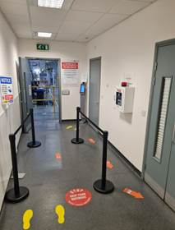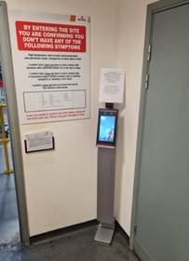

There is a simple process to follow by everyone:

* **Wear your face mask at all time**
* **Ensure social distancing applied**
* **By entering site you are confirming all the rules listed on board above the camera**
* **Stand on the Foot Prints for camera to take your temperature check**
* **Once “Authentication complete” message is said by terminal you are good to proceed to enter site and wash your hands**
* **You are then not required to fill any forms and not required to attend training room for further checks.**

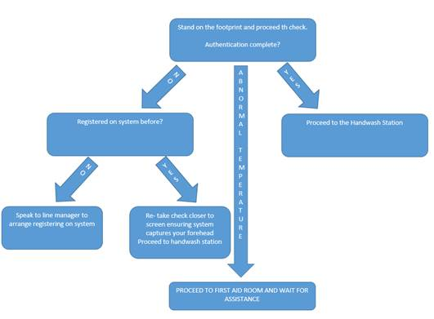

If system does not recognise your face and provides the message as “stranger” it is likely that you have not previously been registered on system. In this case you must fill in the form and go to training room for a temperature screening check. Once completed please speak to your line manager who can arrange the registering on system with the below people:

* Jordan Arnold
* Alan Biddlestone
* Kasper Czarnocki
* Piotr Urban

**In the event of “Abnormal temperature” message delivered by terminal – please make your way back to the first aid room. Email notification will be sent out to relevant group who will be able to assist you ASAP.**